**Hyperparameters for Decision Trees**

In order to create decision trees that will generalize to new problems well, we can tune a number of different aspects about the trees. We call the different aspects of a decision tree "hyperparameters". These are some of the most important hyperparameters used in decision trees:

**Maximum Depth**

The maximum depth of a decision tree is simply the largest possible length between the root to a leaf. A tree of maximum length k*k* can have at most 2k2*k* leaves.

[[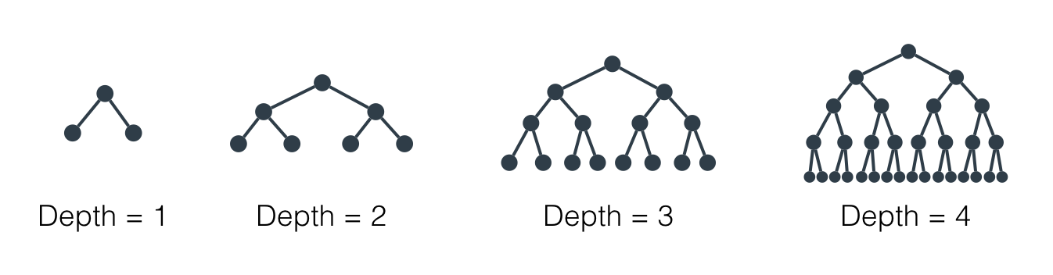](https://classroom.udacity.com/nanodegrees/nd025/parts/c6a7e66b-64f6-41eb-9b3e-e068e0ed962b/modules/aea22017-a8fe-4902-ba79-0d79f161a6bb/lessons/7bf3146d-1583-4e02-96ac-325b275892a7/concepts/e6359cb3-9797-490d-9b86-f9bfb321138d)](https://classroom.udacity.com/nanodegrees/nd025/parts/c6a7e66b-64f6-41eb-9b3e-e068e0ed962b/modules/aea22017-a8fe-4902-ba79-0d79f161a6bb/lessons/7bf3146d-1583-4e02-96ac-325b275892a7/concepts/e6359cb3-9797-490d-9b86-f9bfb321138d)

[Maximum depth of a decision tree](https://classroom.udacity.com/nanodegrees/nd025/parts/c6a7e66b-64f6-41eb-9b3e-e068e0ed962b/modules/aea22017-a8fe-4902-ba79-0d79f161a6bb/lessons/7bf3146d-1583-4e02-96ac-325b275892a7/concepts/e6359cb3-9797-490d-9b86-f9bfb321138d)

**Minimum number of samples to split**

A node must have at least min_samples_split samples in order to be large enough to split. If a node has fewer samples than min_samples_split samples, it will not be split, and the splitting process stops.

[[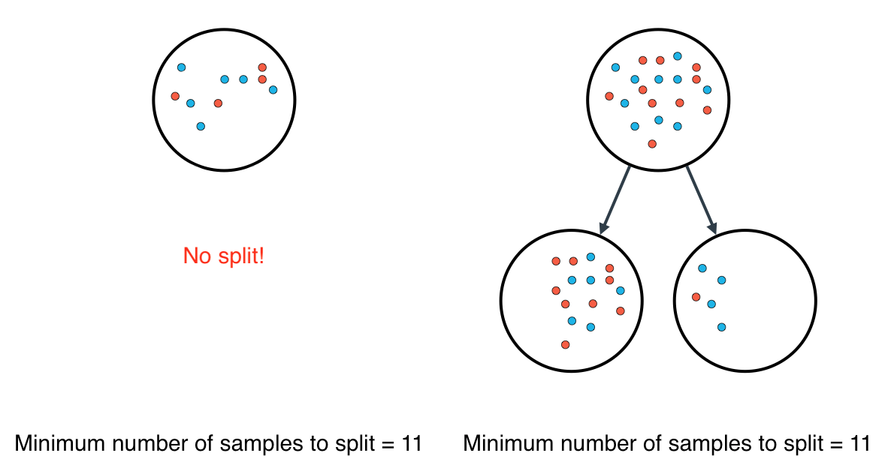](https://classroom.udacity.com/nanodegrees/nd025/parts/c6a7e66b-64f6-41eb-9b3e-e068e0ed962b/modules/aea22017-a8fe-4902-ba79-0d79f161a6bb/lessons/7bf3146d-1583-4e02-96ac-325b275892a7/concepts/e6359cb3-9797-490d-9b86-f9bfb321138d)](https://classroom.udacity.com/nanodegrees/nd025/parts/c6a7e66b-64f6-41eb-9b3e-e068e0ed962b/modules/aea22017-a8fe-4902-ba79-0d79f161a6bb/lessons/7bf3146d-1583-4e02-96ac-325b275892a7/concepts/e6359cb3-9797-490d-9b86-f9bfb321138d)

[Minimum number of samples to split](https://classroom.udacity.com/nanodegrees/nd025/parts/c6a7e66b-64f6-41eb-9b3e-e068e0ed962b/modules/aea22017-a8fe-4902-ba79-0d79f161a6bb/lessons/7bf3146d-1583-4e02-96ac-325b275892a7/concepts/e6359cb3-9797-490d-9b86-f9bfb321138d)

However, min_samples_split doesn't control the minimum size of leaves. As you can see in the example on the right, above, the parent node had 20 samples, greater than min_samples_split = 11, so the node was split. But when the node was split, a child node was created with that had 5 samples, less than min_samples_split = 11.

**Minimum number of samples per leaf**

When splitting a node, one could run into the problem of having 99 samples in one of them, and 1 on the other. This will not take us too far in our process, and would be a waste of resources and time. If we want to avoid this, we can set a minimum for the number of samples we allow on each leaf.

[[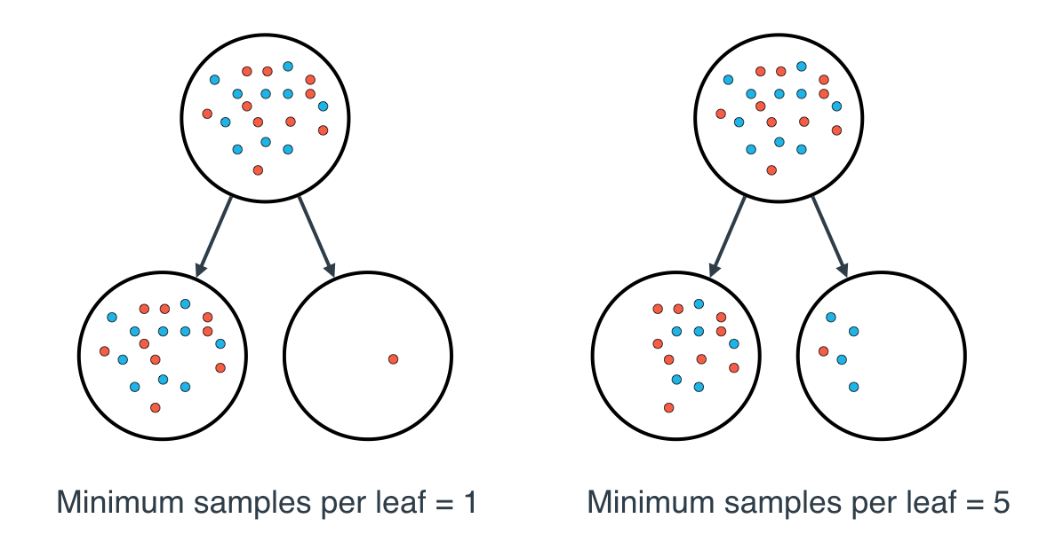](https://classroom.udacity.com/nanodegrees/nd025/parts/c6a7e66b-64f6-41eb-9b3e-e068e0ed962b/modules/aea22017-a8fe-4902-ba79-0d79f161a6bb/lessons/7bf3146d-1583-4e02-96ac-325b275892a7/concepts/e6359cb3-9797-490d-9b86-f9bfb321138d)](https://classroom.udacity.com/nanodegrees/nd025/parts/c6a7e66b-64f6-41eb-9b3e-e068e0ed962b/modules/aea22017-a8fe-4902-ba79-0d79f161a6bb/lessons/7bf3146d-1583-4e02-96ac-325b275892a7/concepts/e6359cb3-9797-490d-9b86-f9bfb321138d)

[Minimum number of samples per leaf](https://classroom.udacity.com/nanodegrees/nd025/parts/c6a7e66b-64f6-41eb-9b3e-e068e0ed962b/modules/aea22017-a8fe-4902-ba79-0d79f161a6bb/lessons/7bf3146d-1583-4e02-96ac-325b275892a7/concepts/e6359cb3-9797-490d-9b86-f9bfb321138d)

This number can be specified as an integer or as a float. If it's an integer, it's the minimum number of samples allowed in a leaf. If it's a float, it's the minimum percentage of samples allowed in a leaf. For example, 0.1, or 10%, implies that a particular split will not be allowed if one of the leaves that results contains less than 10% of the samples in the dataset.

If a threshold on a feature results in a leaf that has fewer samples than min_samples_leaf, the algorithm will not allow *that* split, but it may perform a split on the same feature at a *different threshold*, that *does* satisfy min_samples_leaf.